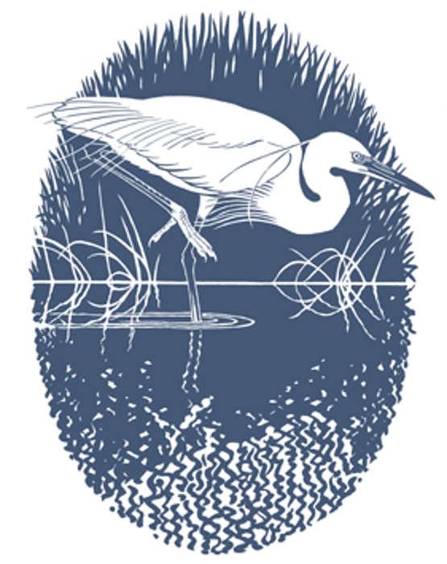

Carmarthenshire Bird Club
Clwb Adar Sir Gaerfyrddin

MINUTES OF AGM HELD AT THE CRICKET CLUB, LLANELLI
AT 7.30pm ON 12th OCTOBER 2022

- Apologies and attendance –
- 31 members were present.
- apologies were received from Rob Hunt, Stuart Blackmore, John Davis, Jill Davies, Ray Davies, Ruth and Mair Harry and Huw Francis.

- Minutes of the 2021 Annual General Meeting – The minutes were approved without alteration.

- Chairman’s Report – The Chairman welcomed everyone to the AGM.

The Chair also advised:

The last couple of years have been difficult for the bird club, although at the same time some aspects of the club's value have been reinforced as members have enjoyed meeting up with friends and fellow birders at club events. That being said, myself and the committee see this as a bit of a relaunch, getting back on an even keel and refocusing the direction of the club. We're looking to increase the ratio of talks about the environment and conservation in the county, with fewer of my holiday snaps. At the same time this will broaden the range of speakers.

Again, if any of you have a story to tell – about your local patch, about special birds in your area, about bird conservation work you have been involved with – do come forward. You will be welcomed with open arms.

Another aspect of this is that for a club to renew itself it needs new people to be involved in running it. Let me assure you – that if anyone wishes to join the committee you will be welcome, no one will feel upset or usurped and you will be helped to perform whatever role you take on – renewal means engaging with new people. One of the important jobs the committee will do is to review the finances of the club and consider whether we need to put the membership fee up. (So, pay up now and avoid the rise.) We do need a new club secretary to take and distribute minutes and maintain membership lists as well as a new event’s organiser – which should be self-explanatory. At the moment, people are doubling up and we're just muddling through.

On that note I want to thank the current committee, who perform a lot of essential administrative tasks like maintaining membership lists, and other thankless donkey work as well as Rob who edited another bird report. The erratum is a printers' error, and we are pursuing this with them.

Another aspect of renewal is modernisation – electronic mailing saves a lot of money, and it really helps if we know your email, address and telephone is up to date – can anyone who didn't get their AGM documentation via email please email the club via the CONTACT (General Enquiries) tab on the website. You may have noticed that postage has become very expensive, and this will save a lot of money, as well as being much quicker and more efficient. I will collate the email contacts and please ask anyone you know who isn't here, to contact us so we can get this up to date.

Finally, you will know that the government is planning to revoke all EU law on the statute book. This includes essential core environmental protections. Without these laws the countryside will be defenceless – and we know the current situation is already bad enough. I urge you all to write to your MP’s asking them to ensure the countryside is protected.

- Election of Officers and Committee

The following people were elected to the posts up for election.

- Gary Harper - County Bird Recorder.
Nominated by Adam Dare and seconded by John Ellis and Wendell Thomas
- Vacant Secretary post – No nominations received.
- Event’s organiser – No nominations received.

- Treasurer’s Report –

The Treasurer reported an income of £1561.99 and expenditure of £1409.00. Showing a slight profit of £152.99 for the year.
Still left a current account balance of £360.65 and a deposit account reserve of £1050.72. With a total Asset of £1756.04 @ 31.08.2022

It was advised that there would be an additional 4 years of gift aid to be added to the account which would amount to approximately £500 but has not yet been received.

Veronica stated that not a lot of people knew whether they had contributed to gift aid or not. Adam advised all to contact us via the committee members or the website and we would respond to them directly.

It was asked, as the cost of the bird report was high would it be a better option to go down the route of an electronic report? The committee responded that they would look into the possibility.

There were no further questions regarding the presentation of the accounts, and they were accepted unanimously.

- Appointment of an Auditor - Member John Evans agreed to become Auditor for the coming year.

- Any other Business
No other business was raised.

