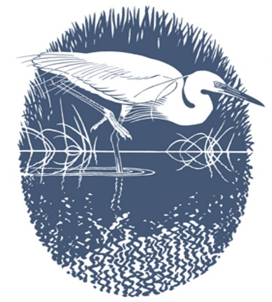

Carmarthenshire Bird Club
Clwb Adar Sir Gaerfyrddin

The nineteenth Annual General Meeting of the Carmarthenshire Bird Club will be held at the WWT Penclacwydd on Wednesday 25th October 2023 at 7:30 p.m.
AGENDA
1. Apologies for absence.
2. Minutes of the eighteenth Annual General Meeting. (Copies will also be available at the meeting)
3. Chairman’s report.
4. Election of Officers and Committee for the period 2023 – 2026 (nomination form included in this mailing)
5. To receive the accounts for the years 2022-2023 (copies will be available at the meeting) and the financial report.
6. To appoint a person to independently examine the accounts for the year 2023-2024.
7. Any other business

Following the AGM,
- there will be an illustrated talk by Sophie-Lee Williams on “Restoring White-tailed Eagles to Southeast Wales”.

The evening will finish with tea/coffee and biscuits - £1-70 charge.

-----------------------------------------------------------------------------------------------------------------------------

The subscription for next year is due and should be sent to the treasurer or can be handed in at the AGM.
A receipt is not normally given for the club subscription but is available on request. If you wish a receipt, please enclose a stamped addressed envelope or alternatively provide your email address.

If you are a taxpayer, please will you help the club by ticking the Gift Aid box.

Please tick:

Single membership - £10

Joint membership (two people at the same address) - £15

Family membership - £15

Please complete this slip and return it with your subscription. Cheques to be made payable to “Carmarthenshire Bird Club”.

Name(s) - _________________________________________________________________________

Email Address - _____________________________________________________________________

Telephone number - __________________________________________________________________

